Strategic Goods control Request:
From Daivd GHLim, 25 Feb 2010
As discuss we will group this part storer as strategic group. Only 5338D1 will be the location for this part now. There will be a message appear on the ITS.

1. Strategic part location to be store will be 5338D1.
2. System do not allow other location update than the define location.

This will give the admin to check and confirm that the store has putaway to define strategic location.
For Outbound the message will be.
- Please check with IBM can we released the shipment.
Eg.
SKU = 77P9093- RENESAS - Strategic Goods

ASR 2886 - Changes: [1 March 2010]
- SKU – SKU.SKUGroup = “Strategic” , PutawayLoc = dedicated location ( = 5338D1)
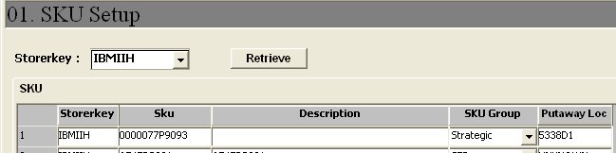

- ITS – message : “* Strategic Part – Putaway location will be 5338D1* ”
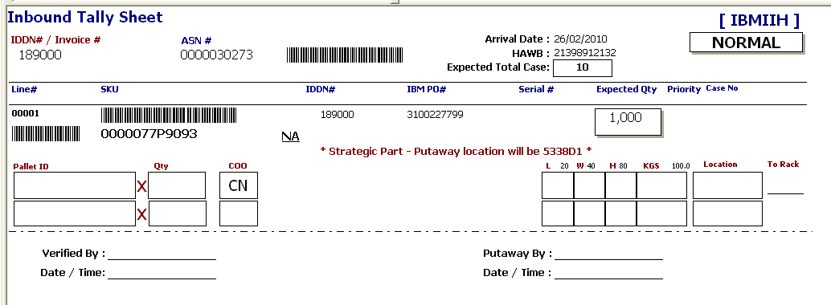
- RF Receiving
System prompts and disallows receiving to non-dedicated put-away location.
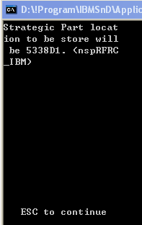

- Outbound:
When Allocation,
System will prompt Query:
“Strategic Part found. Please check with IBM for release of shipment.
Continue allocation? ”

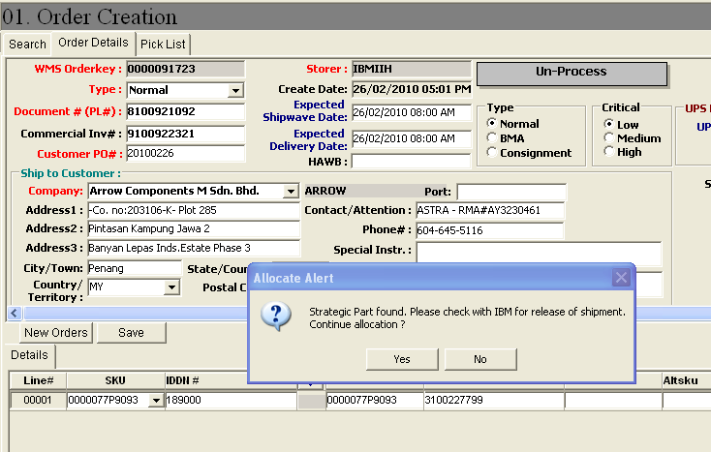

- Pick List
